**Part II – 50 MHz**

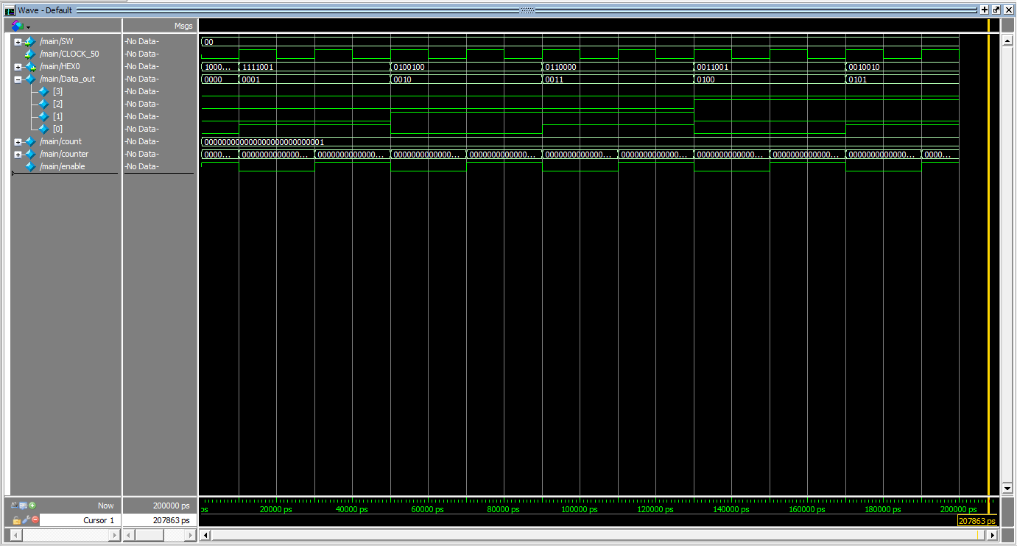

**Part II – 2 Hz**

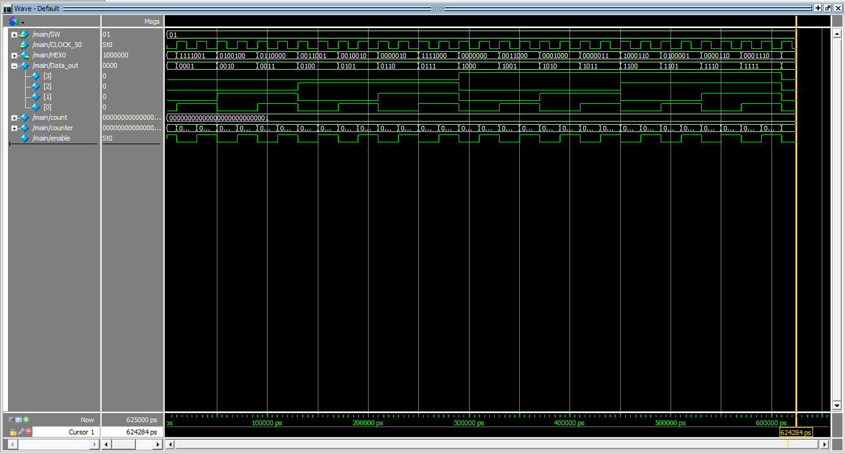

CLK Signal

**Part II – 1 Hz**

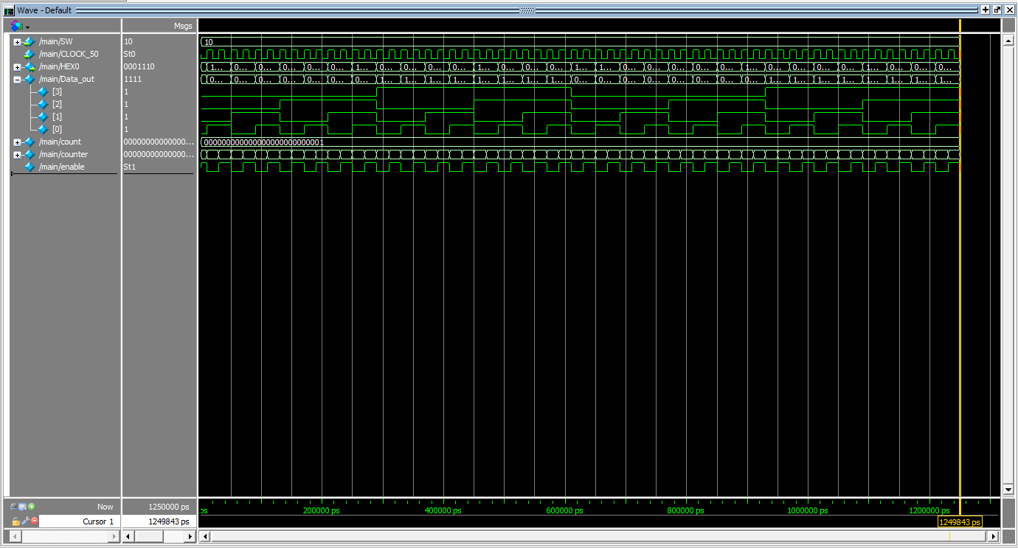

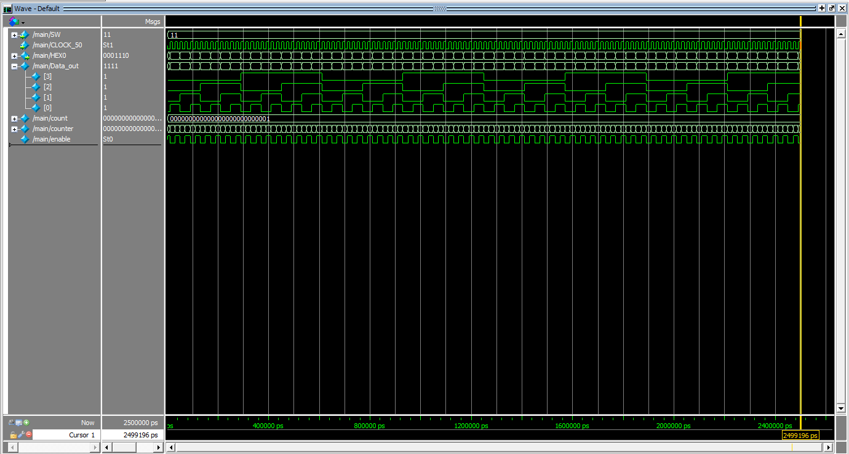**Part II – 0.5 Hz**